Calculate the Contribution of Each Stock to the Index
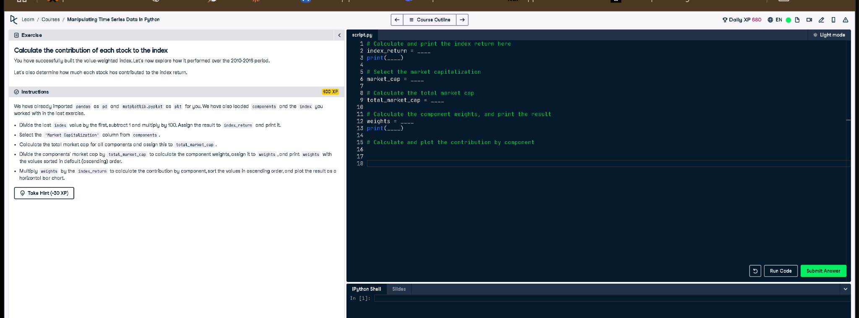

Corrected Code Answer
# Calculate and print the index return here
index_return = (index[-1] / index[0] - 1) * 100
print(index_return)
# Select the market capitalization
market_cap = components['Market Capitalization']
# Calculate the total market cap
total_market_cap = market_cap.sum()
# Calculate the component weights, and print the result
weights = market_cap / total_market_cap
print(weights.sort_values())
# Calculate and plot the contribution by component
contributions = weights.mul(index_return)
contributions.sort_values().plot(kind='barh', title='Index Contribution by Component')
plt.show()

Explanation
This script calculates how much each stock contributed to the index's growth. The return is calculated from the first and last index values. Market cap weights are calculated, and then multiplied using `.mul()` by the index return to find the contribution of each stock. Finally, the contributions are visualized in a horizontal bar chart.

